**WEB PROGRAMMING**

**18CSL36**

**Name: Venkatesh G Dhongadi**

**USN**: **2GI19CS175**

**Semester and Division: III C**

**Course Objectives:**

1. To introduce the fundamentals of world wide web.
2. To develop client based web pages using HTML5 ,CSS3,Javascript,Jquery and Angular JS.
3. To develop responsive web pages using bootstrap.

**Course Outcomes:**

At the end of the course the student will be able to

1. Explain basic concepts and principles of world wide web.
2. Apply design prciples for interactive client side web page.
3. Design and develop responsive website for a given application.

**Term Work – 1**

**Problem Statement :**

1. Create multi column article using HTML tags. Integrate social sharing feature.

Implement both web view and mobile view.

**Program Source Code:**

<!DOCTYPE html>

<html>

<head>

<title> Multi Column Article </title>

<style>

.article {

column-count : 4 ;

column-width : 100px ;

column-gap : 40px ;

column-rule-color: red ;

column-rule-width: 15px ;

column-rule-style: solid ;

}

h1 {column-span :all;}

#share_buttons img{

width: 15px;

padding:5px;

border: 0;

box-shadow: 0;

display: inline;

}

</style>

</head>

<body>

<div class="article">

<h1>This is Spanning all columns.this is spanning all columns</h1>

<p>lorem ipsum dolor sit amet, consectetur adipiscing elit. Praesent eu efficitur tellus. Nam in nisi sed sapien lobortis sodales. Maecenas at eleifend turpis. Duis non maximus ligula. Nunc rutrum diam quis cursus interdum. Nulla viverra dolor et tellus consectetur, et congue enim blandit. Proin non sem dui. Integer porta cursus dolor sed laoreet. Pellentesque non turpis sit amet eros imperdiet suscipit. Sed quis efficitur ipsum, eu ornare tellus. Aliquam orci est, ultrices non cursus sit amet, placerat nec nisl. Nulla ligula est, viverra a nibh ac, accumsan bibendum lacus. Quisque ut sagittis lectus. Aliquam tincidunt in nunc eu hendrerit.Duis nulla enim, rutrum eget arcu vel, pharetra cursus lacus. Aliquam ultricies, ex nec iaculis congue, ante elit lacinia metus, eget congue lorem est eu risus. Pellentesque nec massa turpis. Fusce eu augue non lorem maximus commodo in quis mauris. Aenean id viverra nisi, id lacinia ligula. Nunc viverra dolor id turpis sollicitudin, eget cursus turpis tempor.

</p>

<h1>This is Spanning all columns.this is spanning all columns</h1>

<p>lorem ipsum dolor sit amet, consectetur adipiscing elit. Praesent eu efficitur tellus. Nam in nisi sed sapien lobortis sodales. Maecenas at eleifend turpis. Duis non maximus ligula. Nunc rutrum diam quis cursus interdum. Nulla viverra dolor et tellus consectetur, et congue enim blandit. Proin non sem dui. Integer porta cursus dolor sed laoreet. Pellentesque non turpis sit amet eros imperdiet suscipit. Sed quis efficitur ipsum, eu ornare tellus. Aliquam orci est, ultrices non cursus sit amet, placerat nec nisl. Nulla ligula est, viverra a nibh ac, accumsan bibendum lacus. Quisque ut sagittis lectus. Aliquam tincidunt in nunc eu hendrerit.Duis nulla enim, rutrum eget arcu vel, pharetra cursus lacus. Aliquam ultricies, ex nec iaculis congue, ante elit lacinia metus, eget congue lorem est eu risus. Pellentesque nec massa turpis. Fusce eu augue non lorem maximus commodo in quis mauris. Aenean id viverra nisi, id lacinia ligula. Nunc viverra dolor id turpis sollicitudin, eget cursus turpis tempor.

</p>

</div>

<br>

<br>

<div id ="share-buttons">

<!--Gmail -->

<a href="http://www.gmail.com" target="_blank">

<img src="C:\Users\Riyaz\Pictures\Saved Pictures\Gmail.jpg" alt="gmail">

</a>

<!--Twitter -->

<a href="http://www.twitter.com" target="_blank">

<img src="https://simplesharebuttons.com/images/somacro/twitter.png" alt="twitter">

</a>

<!--Facebook -->

<a href="http://www.facebook.com" target="_blank">

<img src="https://simplesharebuttons.com/images/somacro/facebook.png" alt="facebook">

</a>

<!--Print -->

<a herf="javascript:;" onclick="window.print()">

<img src="https://simplesharebuttons.com/images/somacro/print.png" alt="print">

</a>

<!--Linkedin -->

<a href="http://www.linkedin.com" target="_blank">

<img src="https://simplesharebuttons.com/images/somacro/linkedin.png" alt="linkedin">

</a>

<!--Pinterest -->

<a href="http://www.pinterest.com" target="_blank">

<img src="https://simplesharebuttons.com/images/somacro/pinterest.png" alt="pinterest">

</a>

<!--Reddit -->

<a href="http://www.reddit.com" target="_blank">

<img src="https://simplesharebuttons.com/images/somacro/reddit.png" alt="reddit">

</a>

<!--StumbleUpon -->

<a href="http://www.stumbleUpon.com" target="_blank">

<img src="https://simplesharebuttons.com/images/somacro/stumbleupon.png" alt="stumbleUpon">

</a>

<!--Reddit -->

<a href="http://www.tumblr.com" target="_blank">

<img src="https://simplesharebuttons.com/images/somacro/tumblr.png" alt="tumblr">

</a>

</div>

</body>

</html>

**OUTPUT:**

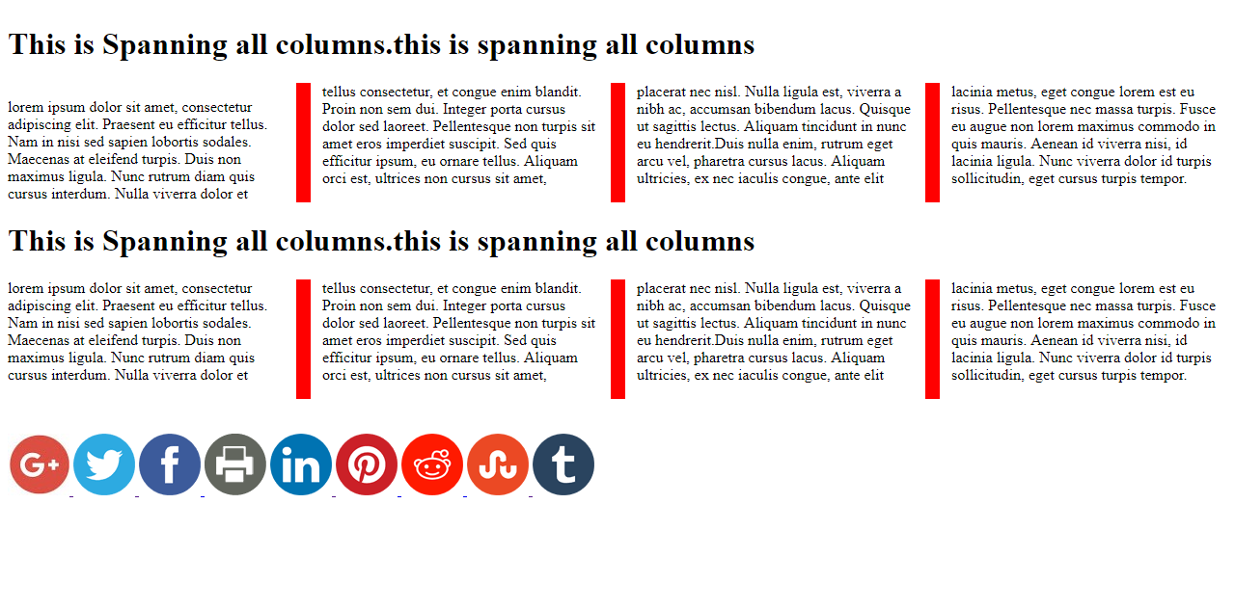

**Term Work – 2**

**Problem Statement :**

2. Implement HTML5 dropdown menu with CSS3 and bootstrap**.**

**Program Source Code:**

<!Doctype html>

<html>

<head>

<title>Dropdown Menu using CSS</title>

<style>

.dropdown {

position: relative;

display: inline-block;

}

.dropdown-content {

display: none;

position: absolute;

background-color: #f9f9f9;

min-width: 160px;

box-shadow: 0px 8px 16px 0px rgba(0,0,0,0.2);

padding: 12px 16px;

z-index: 1;

}

.dropdown:hover .dropdown-content {

display: block;

}

</style>

</head>

<body>

<h1>Hoverable Dropdown</h1>

<p>Move the mouse cursor over the text below to open the dropdown content</p>

<div class="dropdown">

<span>Web Programming Languages</span>

<div class="dropdown-content">

<p>HTML</p>

<p>CSS</p>

<p>Javascript</p>

<p>AngularJS</p>

<p>PHP</p>

</div>

</div>

</body>

</html>

**OUTPUT :**

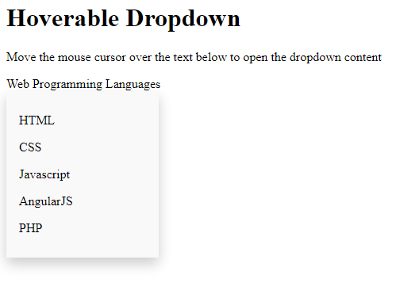

**Term Work - 3**

**Problem Statement :**

3. Implement HTML5 Local Storage.

**Program Source Code:**

Implement HTML Local Storage

<!DOCTYPE html>

<html>

<head>

<title>Web Local Storage</title>

</head>

<body>

<div id="local"></div>

</body>

<script>

if(typeof(Storage) !== "undefined"){

localStorage.setItem("MyUSN", "2GI19CS027");

document.getElementById("local").innerHTML = localStorage.getItem("MyUSN");

}

else{

document.getElementById("local").innerHTML = "Sorry your browser doesnot support.";

}

</script>

</html>

**OUTPUT**

**1)**

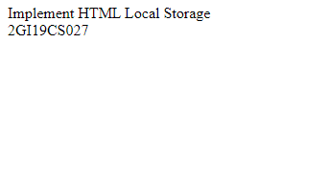

**Term Work – 4**

**Problem Statement :**

4. Form Validation using HTML5, JavaScript, angularJS and Bootstrap.

**Program Source Code:**

Form Validation using HTML5, JavaScript, angularJS and Bootstrap.

<!DOCTYPE html>

<html>

<head>

<!-- CSS -->

<link rel="stylesheet" href="lib/bootstrapA.min.css">

<style>

body { padding-top:30px; }

.container {

width: 50%;

text-align: center;

margin: 0 auto;

padding: 20px;

background: #f0e68c;

}

</style>

<!-- JS -->

<script src="lib/angular.js"></script>

<script src="app.js"></script>

</head>

<body ng-app="validationApp" ng-controller="mainController">

<div class="container" >

<!-- PAGE HEADER -->

<div class="page-header"><h1>Form Validation</h1></div>

<!-- pass in the variable if our form is valid or invalid -->

<form name="userForm" ng-submit="submitForm(userForm.$valid)" novalidate>

<!-- EMAIL -->

<div class="form-group" ng-class="{ 'has-error' : userForm.email.$invalid && !userForm.email.$pristine }">

<label>Email</label>

<input type="email" name="email" class="form-control" ng-model="user.email" required>

<p ng-show="userForm.email.$invalid && !userForm.email.$pristine" class="help-block">Enter a valid email.</p>

<br>

Password:<input type="password" name="pwd1" />

Confirm&nbsp;&nbsp;:<input type="password" name="pwd2"/>

</div>

<button type="submit" class="btn btn-primary" onclick="checkPass()">Submit</button>

<!--button type="submit" class="btn btn-primary" onclick="checkPass()">Password</button-->

</form>

</div>

</body>

</html>

**OUTPUT**

**1)**

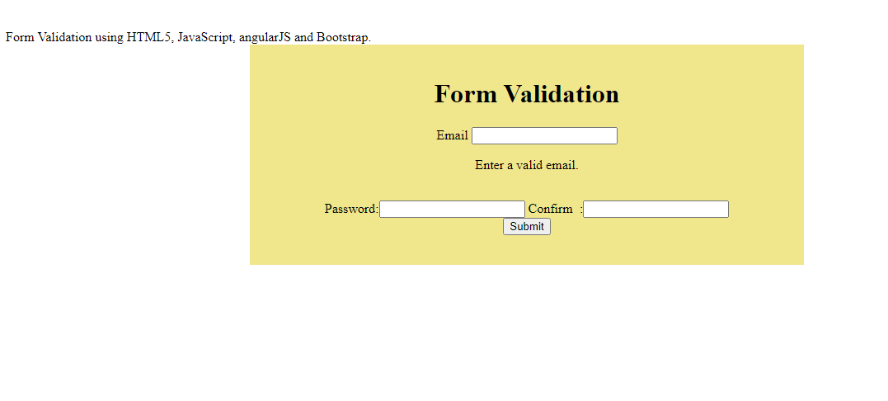

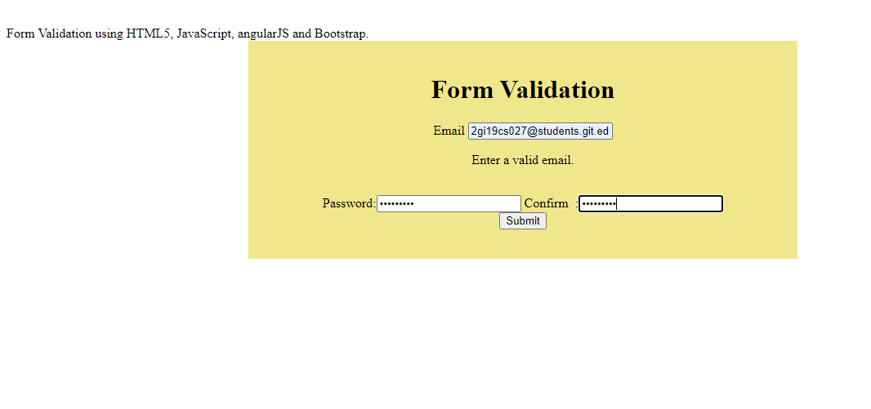

**Term Work – 5**

**Problem Statement :**

5. Implement Angular Routing and AngularJS Controller.

**Program Source Code:**

<!DOCTYPE html>

<html>

<script src="lib/angular.min.js"></script>

<script src="lib/angular-route.js"></script>

<body ng-app="myApp">

<p><a href="#!I">India</a></p>

<p><a href="#!K">Karnataka</a></p>

<p><a href="#!B">Belagavi</a></p>

<div ng-view></div>

<script>

var app = angular.module("myApp", ["ngRoute"]);

app.config(function($routeProvider) {

$routeProvider

.when("/I", {

template : "<H1>India is a land of diversity</H1>"

})

.when("/K", {

template : "<H2>Karnataka is one of the Largest State in India</H2>"

})

.when("/B", {

template : "<H3>Belagavi is the Biggest District in Karnataka</H3>"

});

});

</script>

</body>

</html>

**OUTPUT**

**1)**

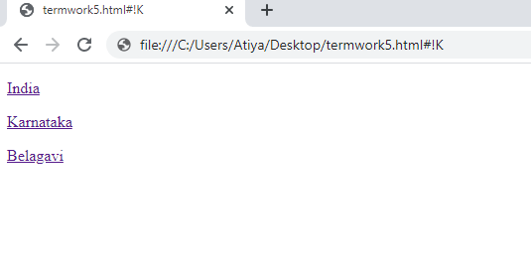

**Term Work – 6**

**Problem Statement :**

6. Implement UI Datepicker using Jquery.

**Program Source Code:**

<!doctype html>

<html lang = "en">

<head>

<meta charset = "utf-8">

<title>jQuery UI Datepicker functionality</title>

<link href = "lib/jquery-ui.css" rel = "stylesheet">

<script src="lib/jquery-1.10.2.js"></script>

<script src="lib/jquery-ui.js"></script>

<!--script src = "https://code.jquery.com/jquery-1.10.2.js"></script>

<script src = "https://code.jquery.com/ui/1.10.4/jquery-ui.js"></script-->

<!-- Javascript -->

<script>

$(function() {

$( "#StartDate" ).datepicker({

showOn:"button",

buttonImage: "calendar-icon.png",

buttonImageOnly: true

});

});

$(function() {

$( "#ReturnDate" ).datepicker({

showOn:"button",

buttonImage: "calendar-icon.png",

buttonImageOnly: true

});

});

</script>

</head>

<body>

<!-- HTML -->

<p>Start Date: <input type = "text" id = "StartDate"></p>

<p>Return Date: <input type = "text" id = "ReturnDate"></p>

<p><label name="lblName" id="StartDate"></label></p>

</body>

</html>

**OUTPUT**

**1)**

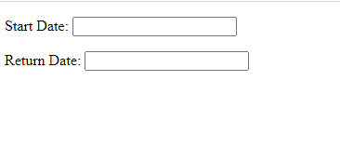

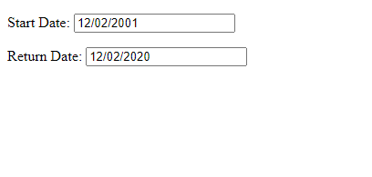

**Term Work – 7**

**Problem Statement :**

7. Implement Drag and drop using, HTML5 and Jquery.

**Program Source Code:**

<!DOCTYPE HTML>

<html>

<head>

<style>

#div1 ,#div2 {

float : left;

width: 200px;

height:200px;

margin: 50px;

padding: 50px;

border: 1px solid black;

}

</style>

<script>

function allowDrop(ev) {

ev.preventDefault();

}

function drag(ev) {

ev.dataTransfer.setData("text", ev.target.id);

}

function drop(ev) {

ev.preventDefault();

var data = ev.dataTransfer.getData("text");

ev.target.appendChild(document.getElementById(data));

}

</script>

</head>

<body>

<p>Drag the heading into the rectangle:</p>

<div id="div1" ondrop="drop(event)" ondragover="allowDrop(event)">

<img id="drag1" src="C:\Users\Riyaz\Pictures\Saved Pictures\Gmail.jpg" draggable="true" ondragstart="drag(event)" width="200" height="200" >

</div>

<div id="div2" ondrop="drop(event)" ondragover="allowDrop(event)"></div>

</body>

</html>

**OUTPUT**

**1)**

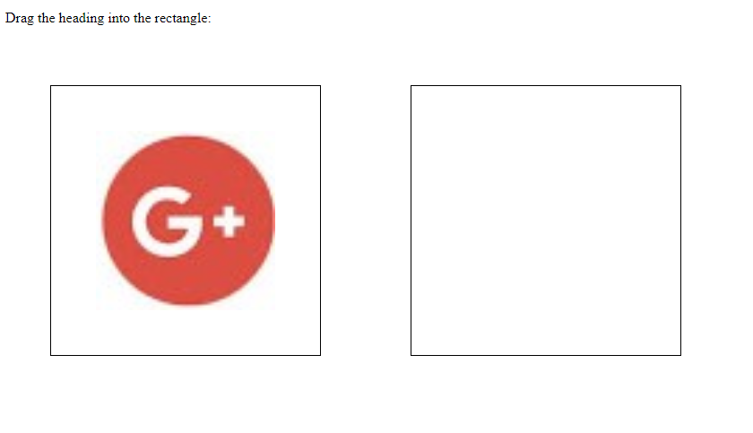

**2)**

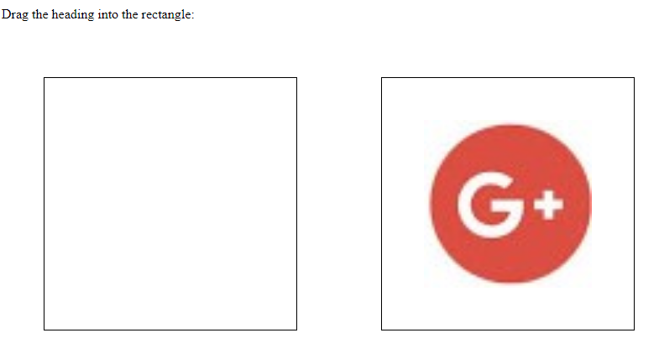

**Term Work – 8**

**Problem Statement :**

8. Implement UI Autocomplete using Jquery

**Program Source Code:**

<!doctype html>

<html lang = "en">

<head>

<meta charset = "utf-8">

<title>jQuery UI Autocomplete functionality</title>

<link href = "https://code.jquery.com/ui/1.10.4/themes/ui-lightness/jquery-ui.css"

rel = "stylesheet">

<script src = "https://code.jquery.com/jquery-1.10.2.js"></script>

<script src = "https://code.jquery.com/ui/1.10.4/jquery-ui.js"></script>

<!-- Javascript -->

<script>

$(function() {

var availableTutorials = [

"ActionScript",

"Bootstrap",

"C",

"C++",

];

$( "#automplete-2" ).autocomplete({

source: availableTutorials,

autoFocus:true

});

});

</script>

</head>

<body>

<!-- HTML -->

<div class = "ui-widget">

<p>Type "a" or "s"</p>

<label for = "automplete-2">Tags: </label>

<input id = "automplete-2">

</div>

</body>

</html>

**OUTPUT**

**1)**

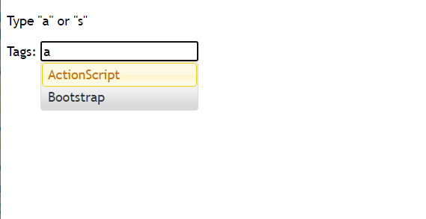

**2)**

